**SECTION 3.2**

**1.** Determine an equation for the line shown with   
each triangle.

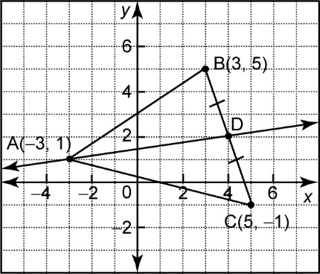 **a)**

**3.** **a)** Verify that △DEF is isosceles.

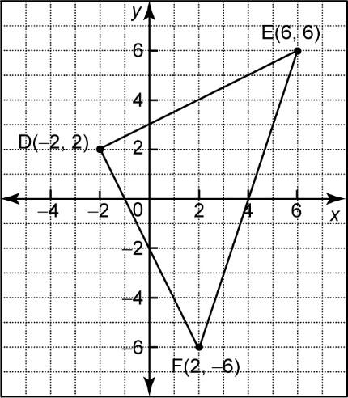

**b)** Verify that the median from vertex D   
is also an altitude of the triangle.

**7. a)** Draw the triangle with vertices A(−14, 6),   
 B(2, 0), and C(−10, −6).

**b)** Determine the coordinates of D, the   
midpoint of AB, and E, the midpoint of AC.

**c)** Verify that DE is parallel to BC.

**d)** Verify that BC is twice the length of DE.

**SECTION 3.4**

**3.** Verify that quadrilateral DEFG is a kite.

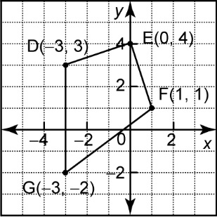

**5. a)** Draw the quadrilateral with vertices   
 S(−2, 4), T(− 4, −2), U(2, − 4), and V(4, 0).

**b)** Find the midpoint D of side ST, the midpoint E of side TU, the midpoint F   
of side UV, and the midpoint G of side VS. Join the midpoints of adjacent sides to form a new quadrilateral DEFG.

**c)** Verify that opposite sides of DEFG are   
parallel.

**d)** Verify that opposite sides of DEFG are   
equal in length.

**7. a)** Draw the trapezoid with vertices P(−3, 3),   
 Q(2, 4), R(6, −1), and S(− 4, −3).

**b)** Verify that the line segment joining the midpoints of the non-parallel sides of the trapezoid is parallel to the other two sides.

**ANSWERS 3.2**

**1.** **a)** *y* = *****x* + 

**3. a)** DE = , DF = , EF =   
 Since DE = DF = , △DEF is isosceles.

**b)** The midpoint of EF is M(4, 0). Therefore, the   
 median from vertex D is DM.

Since *m*DM =  and *m*EF = 3, *m*DM × *m*EF = −1, so   
 DM is perpendicular to EF, which makes DM an   
 altitude of the triangle.

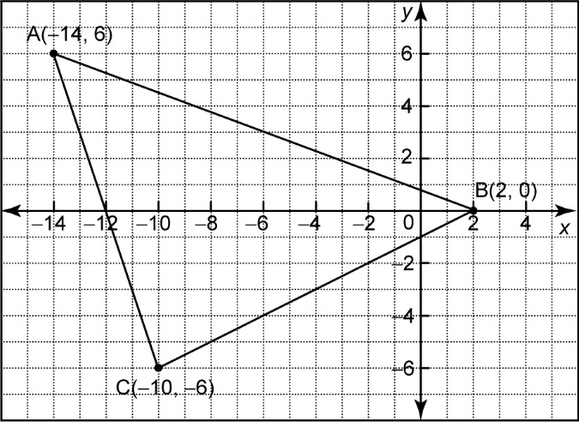**7. a)**

**b)** D(−6, 3), E(−12, 0)

**c)** Since *m*DE = *m*BC = , DE is parallel to BC.

**d)** BC =  and DE = . Therefore, BC is twice   
 the length of DE.

**ANSWERS 3.4**

**3.** Since DE = EF =  and DG = GF = 5,  
quadrilateral DEFG is a kite.

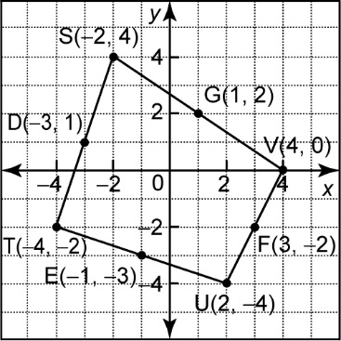**5. a), b)**

**c)** *m*DE = −2, *m*EF = , *m*FG = −2, *m*DG = 

Since *m*DE = *m*FG, DE is parallel to FG.

Since *m*EF = *m*DG, EF is parallel to DG.

**d)** DE = , EF = , FG = , and   
 DG = . Since DE = FG and EF = DG,  
 the opposite sides of DEFG are equal in length.

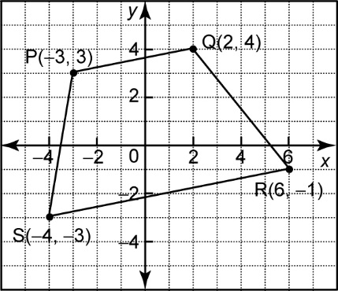**7. a)**

**b)** The midpoints of the non-parallel sides PS and QR   
 are E and F, respectively;   
 *m*PQ = , *m*SR = , and *m*EF = .  
 Since *m*PQ = *m*SR = *m*EF, EF is parallel to PQ and EF   
 is also parallel to SR.