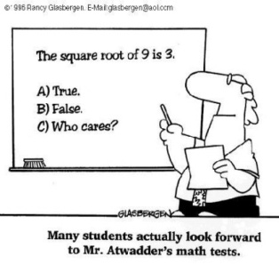
3UI - Unit 5 Trigonometric Ratios & Identities
At the end of the unit students will be able to:
- determine the values of the trigonometric ratios for angles less than 360º; prove simple trigonometric identities; and solve problems using the primary trigonometric ratios, the sine law, and the cosine law;
Date | Topic | Practise
Wed. Nov. 5 | 5A Trigonometric Ratios  5.1 Trig Ratios of Acute Angles  LG: to be able to evaluate reciprocal trig ratios | p. 280 #1 – 12, 14 [18, 20]
Thurs. Nov. 6 | 5.2 Trig Ratios of Special Angles  LG: to evaluate exact values for trig ratios with special angles | p. 286 # 1 – 9 [13 – 15]
Fri. Nov. 7 | PD Day
Mon. Nov. 10 | 5.3 Trig Ratios of Obtuse Angles  5.4 CAST Rule & Related Acute Angles  LG: to use the Cartesian Plane to evaluate primary trig ratios for angles in 1 rotation | p. 292 #1 – 4  p. 299 #1 - 5
Tues. Nov. 11 | 5.3 Trig Ratios of Obtuse Angles cont…  5.4 CAST Rule & Related Acute Angles cont… | p. 292 #1 – 4  p. 299 #1 - 5
Wed. Nov. 12 | Practise Day | p. 299 #6 – 9ace, 10, 12 [15]  Review p. 304
Thurs. Nov. 13 | Quiz  5.6 Sine Law  LG: to solve 2-D problems involving Sine Law | p. 318 #1, 2, 3a, 4, 5ac, 7 [15,17]
Fri. Nov. 14 | 5.7 Cosine Law  LG: to solve 2-D problems involving Cosine Law | p. 325 #1b, 2b, 3bc, 4ac, 5, 6, 8 [12,14]
Mon. Nov. 17 | Quiz  5.8 3-D Problems  LG: to solve 3-D problems using trigonometry | p. 332 #3 – 6 [7, 14]
Tues. Nov. 18 | Review | p. 338 #1 – 13  p. 340 #2
Wed. Nov. 19 | Unit Test
Thurs. Nov. 20 | 5B Trigonometric Identities  5.5 Trig Identities  LG: to prove simple trig identities | p. 310 #1 – 6
Fri. Nov. 21 | 5.5 Trig Identities cont… | p. 310 # 8, 10 – 12 [14]  Worksheet
Mon. Nov. 24 | Review | p. 339 #6, 7  p. 340 #4
Tues. Nov. 25 | Evaluation | p. 344 #1 – 7  (If any of these understandings are missing, get help ASAP!)

