**MSIP ASSIGNMENT FOR GRAPHICAL MODELS**

Name: ____________________

1. Identify each of the following as linear, quadratic or neither**. Justify your answers.**

|  |  |
| --- | --- |
| x | y |
| -1 | 1 |
| 0 | 0 |
| 1 | 1 |
| 2 | 4 |
| 3 | 9 |

1. c.

[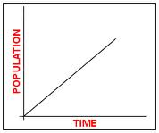](http://images.google.com/imgres?q=linear+models&hl=en&biw=1366&bih=545&gbv=2&tbm=isch&tbnid=qi05u1SArLlqrM:&imgrefurl=http://www.cpc.unc.edu/measure/training/online-courses/non-certficate-courses/pap/lesson-6&docid=_l4euPIxH9MMBM&imgurl=http://www.cpc.unc.edu/measure/training/online-courses/non-certficate-courses/pap/lesson-6/f6-2.gif&w=223&h=187&ei=t9bbTrWXLKbL0QGY_dWPDg&zoom=1)

1. 3x + y – 4 = 0 d. y = 3x² + 5x - 2
2. Which of these graphs bests represents the relationship between a person’s age and height?

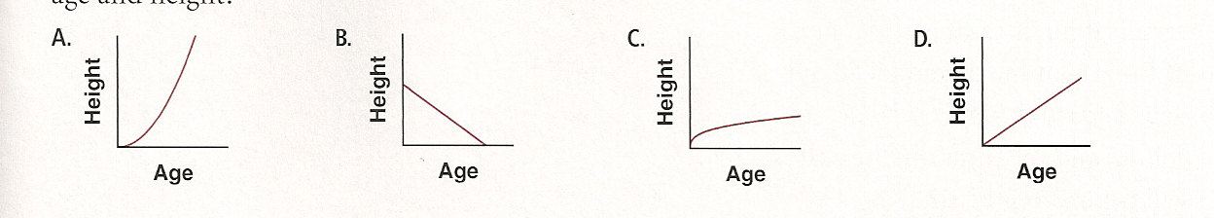

A.

1. ***Describe*** the trends in the graph below.

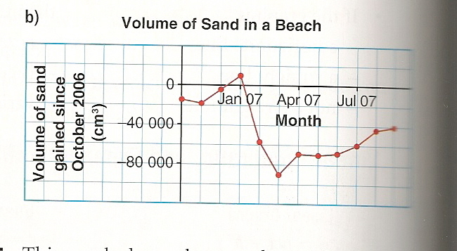

1. As China becomes more industrialized, it’s population consumes more plant oils.

|  |  |  |  |  |  |
| --- | --- | --- | --- | --- | --- |
| YEAR | 1991 | 1993 | 1997 | 2000 | 2004 |
| PER PERSON  CONSUMPTION (g/day) | 23 | 25 | 29 | 33 | 35 |

1. Create a scatter plot of the data, and describe any trends . (sketch graph below)
2. Determine if it is a linear or quadratic model. Determine the equation of the model that best fits the data.
3. Predict China’s consumption of plant oils in 2010.
4. What factors could cause this consumption pattern to change? Explain.



1. A company designs custom prints for promotional beach balls. This table shows the surface areas of different balls.

|  |  |  |  |  |  |
| --- | --- | --- | --- | --- | --- |
| DIAMETER (CM) | 15 | 30 | 45 | 60 | 75 |
| SURFACE AREA (CM²) | 707 | 2827 | 6362 | 11 310 | 17 671 |

1. Create a scatter plot of the data, and describe and trends. (Sketch on grid above)
2. Determine the equation of the parabola of best fit. Graph the parabola on the scatter plot on your graph paper.
3. Predict the surface area of a ball with diameter 122 cm.



6. The median age, A, in each province n years after 1991 is

Prince Edward Island: A = 0.34n + 24

Alberta: A = 0.43n + 24

a) Graph the equations on the same grid. How do they compare?

b) How would the graph for Alberta change if the median age in 1991 was30?

7. The volume of a cone with height, h, and radius, r, is given by the formula V = $\frac{1}{3}$ πr²h.

a) Which variable should you set constant to create a linear relationship? Justify your answer by substituting the value "2" into the equation.

b) Which variable should you set constant to create a quadratic relationship? Justify your answer by substituting the value "2" into the equation.

8. a) Why might a quadratic model be a good fit for the data in the table provided?

|  |  |
| --- | --- |
| Year | Population of  Kingston |
| 2001 | 152 652 |
| 2002 | 154 439 |
| 2003 | 155 676 |
| 2004 | 156 123 |
| 2005 | 155 685 |
| 2006 | 154 971 |

b) Perform a quadratic regression using the graphing calculator. Write the equation below:

c) Do you think the trend modelled by the regression equation will continue? Explain.