EXPONENTIAL FUNCTIONS ASSIGNMENT – ANSWERS
- a) $\frac{1}{27}$ b) $\frac{1}{64}$ c) 1

- a) 5 b) $\frac{5}{3}$ c) $\frac{9}{25}$

- a) $\frac{-17}{y^{4}}$ b) $\frac{9}{16a^{8}}$ c) $\frac{1}{mn^{\frac{1}{2}}}$

- a) $\frac{1}{16}$ b) 625 c) $\frac{1}{9}$

PART B
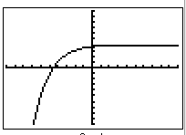
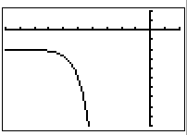
7. a) b)

Each line is one unit in both graphs above.

9. c) $8585.39 d) $7560 e) $25573.13 f) $3418.04 (value after 5 years subtract value after 4 years)
10. b) 16000 c) about 90510

