Chapter 6 Review (Solving Quadratics)

6.2 Solve Quadratic Equations

**5.** Solve by factoring. Check your solutions.

**a)** *x*2 + 2*x* − 15 = 0

**b)** *m*2 − 13*m* + 36 = 0

**c)** 4*y*2 − 8*y* − 5 = 0

**d)** 15*c*2 − 8*c* − 12 = 0

**6.** Solve.

**a)** *y*2 + 2*y* = 8

**b)** 5*x*2 = −8*x* − 3

**c)** 4*z*2 = 1

**d)** 10*m*2 − 40*m* = 0

**e)** 8*x*2 − 40 = 22*x*

**f)** −18*x*2 + 39*x* = −15

**7.** Write a quadratic equation in the form   
*ax*2 + *bx* + *c* = 0, where *a*, *b*, and *c* are integers, given the following roots.

**a)** 5 and −3

**b)**  and 

6.3 Graph Quadratics Using the *x*-Intercepts

**8.** Find the *x*-intercepts and the vertex of each   
quadratic relation. Sketch each graph.

**a)** *y* = *x*2 + 6*x* + 9

**b)** *y* = 25*x*2 − 9

**c)** *y* = −*x*2 + 4*x* + 21

**d)** *y* = *x*2 + 12*x* + 32

**e)** *y* = −2*x*2 + 4*x* + 48

**f)** *y* = 20*x*2 − 5

**9.** Write an equation in the form   
*y* = *ax*2 + *bx* + *c* to represent each parabola.

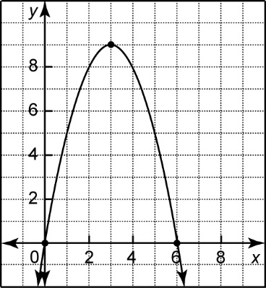**a)**

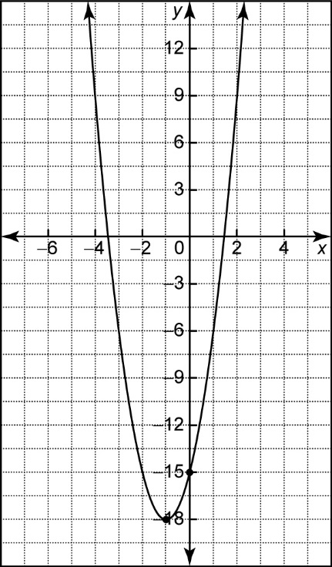**b)**

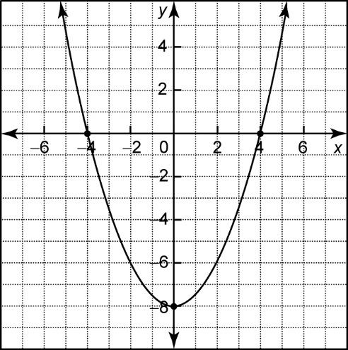**c)**

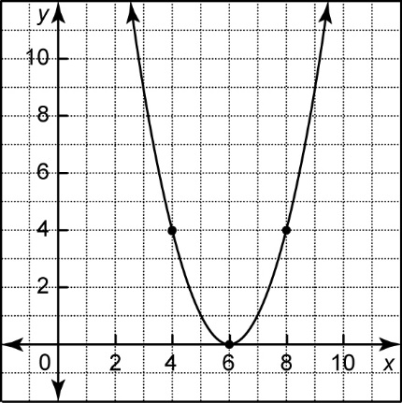**d)**

**10.** A parabola has a vertex (−3, 4) and one   
*x*-intercept is −1. Find the other *x*-intercept and the *y*-intercept.

6.4 The Quadratic Formula

**11.** Use the quadratic formula to solve each equation. Express your answers as exact results.

**a)** *x*2 + 5*x* + 2 = 0

**b)** 3*x*2 + *x* − 1 = 0

**c)** −*x*2 − 6*x* + 4 = 0

**d)** 5*x*2 − 3*x* − 4 = 0

**e)** 2*x*2 + 3*x* – 7 = 0

**f)** 3*x*2 – *x* – 1 = 0

**g)** 2*x*2 + *x* – 5 = 0

**h)** 0 = –3*x*2 + 3*x* + 1

**12.** For each quadratic relation, state the   
coordinates of the vertex and the direction of opening and determine the number of   
*x*-intercepts.

**a)** *y* = 3(*x* + 1)2 + 1

**b)** 

**c)** 

**d)** *y* = −3(*x* + 4)2 − 2

**13.** A toy rocket is launched from a platform that is 2 m off the ground at an initial velocity of 17.4 m/s. The height, *h*, in metres, of the rocket *t* seconds after it is launched is given by the equation *h* = −4.9*t*2 + 17.4*t* + 2.

**a)** How long will it take the toy rocket to   
 reach a height of 9 m, to the nearest tenth   
 of a second?

**b)** When will the toy rocket fall back to the   
 height of 9 m, to the nearest tenth of a   
 second?

**c)** Using your answers from parts a) and b),   
 find the time when the rocket will reach   
 its maximum height and determine this   
 maximum height. Round to the nearest   
 tenth.